The First International Forum on Makers and Education,

第一届国际创客与教育论坛

*“Innovative Educational Practices Shaping the Future of University”*

“创新教育实践塑造大学未来”

Tsinghua University, Beijing. Nov., 2014

**Context: Tsinghua Makers’ Day**

Tsinghua University is embracing many technology-driven educational practices. We believe that Open Source Movement, Creative Commons-like content licensing protocols, and Internet of Things are already shaping the future of education in an accelerated fashion. Working with global educational innovators, we have implemented Massive Online Open Courses (MOOC), Flipped Classroom operations, Hackers in Residence Program, and student-run Hackathons. We consider these educational innovators as hackers and makers of future education. These people are capable of utilizing not only technologies, but also capable of addressing social needs and formulating pragmatic educational practices. As these Hackers/Makers continue to push the envelop of educational practices, we decided to mark the last Saturday of every November as Tsinghua Makers’ Day (创客日).

**Topic: Innovative Educational Practices Shaping the Future of University**

In this conference, we would like to discuss the whether Maker Movement would or wouldn’t change the future of education. If it will change education, why and how would the changes become sustainable? Then, we would also ask the question when, how soon, and what specific sets of circumstances would these changes become dominant in the future of educational practices. We welcome all participants to share their ideas on the digital platform, and we will have many leading personalities in the Maker community to respond to various voices.

The key sub-topics include, but not limited to:

* **What kind of technological and societal resources, and government policies can be recombined to produce positive impacts on education?**
* **Whether and how digital technologies and open source movements are going to affect the way we manage Learning Outcomes?**
* **How and what aspects of hacker/maker culture may have a stronger role in shaping the culture of universities and educational practices?**
* **Will hackathon and other similar activities change the way we conduct existing teaching practice?**
* **How to utilize fragmented human resource and make online interactions to help organize collaborative learning experience?**

**Time and Venue**

13:30 – 17:00, November 29, 2014

Multi-function Room 11-203, ROHM Building, Dept. Electronics Eng.

**Invited Keynote Speakers (Tentative)**

Mitch Altman, Founder of the Hackerspace movement

Luis Felipe, Harvard Berkman Center, An anthropolist’s view of Hacker/Maker Community

Fan Xiang, Professor of Arts

Zhiyong Fu, Maker Activities and Service Design

Lin Zhang, TBD

Luping Xu, Founder of Open Fiesta

Hao Wang, Maker/Entrepreneur

Benjamin Bacon, NYU Shanghai Professor running Hackerspaces in Shanghai

**International Forum: Kicking Off Tsinghua Makers’ Day**

To kickoff Makers’ Day, we have invited a number of international Makers to participate in an open forum. This forum will enable participants to communicate and share information digitally and in a physical venue. The digital forum will be held at the following URL:

“http://toyhouse.cc”

The physical forum will be held on campus at ROHM Building, Electronic Engineering Department of Tsinghua University.

**Meeting in Person: Flipped Conference**

To ensure communication effectiveness on the first Makers’ Day, we cooked up a conference format called ‘Flipped Conference’, with 3 stages

* **Pre-meeting: Video-based online speech review**

One-week ahead of the Forum, all forum participants will **register with digital identities** on a public website (toyhouse.cc).

Invited “Expert” panelists will reveal their key concepts with **short-videos** posted on the public website.

There will a number of invited “**Challengers**” who will study the content and **post questions** to the online discussion forum. Each Challenger has at most one minute to present their questions. They are also allowed to show their questions using whatever media during that one minute.

The host of forum will **review the questions** and decide which 7 challengers will be given the chance to raise their questions during the forum.

* **Within-meeting: Topic-oriented question and answer**

During the Forum, each “Expert” panelist will be given a 5-minute slot to present his or her ideas. Following the speech, the speaker will respond to at least one Challenger‘s prepared question. Then, after at most 9 minutes of interactions, the MC will move to the next “Expert” panelist.

* **Post-meeting: continued interaction with interest**

Host of the forum will keep the online platform open so that all participants could review the content before and during the forum. They could continue on topic of great interest to them.

**Input/output of Speakers/Challengers**

Speakers: Name, photo, bio, title of presentation, one-line slogan, presentation slides, video abstract

Challengers: Name, photo, bio, question

**Pre-forum Discussion: Open, with insight, digitally tracked**

|  |  |  |  |  |
| --- | --- | --- | --- | --- |
| Time | Topic | Content | Venue | Note |
| Nov. 21-26 | Breakout Discussion | Top Makers and Tsinghua Students meet-ups | Toyhouse Studio  (Shunde Bld. 410) |  |
| Nov. 23-26 | Keynote Speeches | 5-min Keynote speech video abstracts are released and being commented. | <http://toyhouse.cc> (online) |  |
| Nov. 24-27 | Questions Review | 1-min Keynote questions will be reviewed and selected | Toyhouse Studio and <http://toyhouse.cc> |  |
| Nov. 28 | Question release | 7 challengers are selected and final questions are released to the public | <http://toyhouse.cc> (online) |  |
| Nov. 29 | Forum | Discussion will be compiled and demonstrated on Forum with more interaction | ROHM Bld. 11-203 |  |

**Forum Agenda: Short, with insight, digitally tracked**

|  |  |  |  |  |
| --- | --- | --- | --- | --- |
| Time | Topic | Content | Venue 罗姆楼 | Note |
| 1300-1330 | Registration |  |  |  |
| 1330-1400 | Warm up | Theme video, report of 7-day discussion | 11-203 |  |
| 1400-1415 | Opening | Introduction, Tsinghua Maker’s Day Inauguration | 11-203 | Master of Conference: Ben Koo |
| 1415-1515 | Section 1 | (5 min talk + 3 min prepared Q&A + 2 * 3 min impromptu Q) * 3 | 11-203 | Each talk includes a keynote speech and a prepared question |
| 1515-1530 | Tea break | Free discussion | Lobby + 11-203 |  |
| 1530-1630 | Section 2 | (5 min talk + 3 min prepared Q&A + 2 * 3 min impromptu Q) * 4 | 11-203 | Each talk includes a keynote speech and a prepared question |
| 1630-1645 | Interactive Section | 5 * 3 min impromptu Qs | 11-203 | WeChat Wall interaction |
| 1645-1700 | Closing | Conference executive report,  Closing talk | 11-203 | Mr. Song Shu-Qiang,  Ben Koo |

**Stage logistics: Dynamic Roundtable**

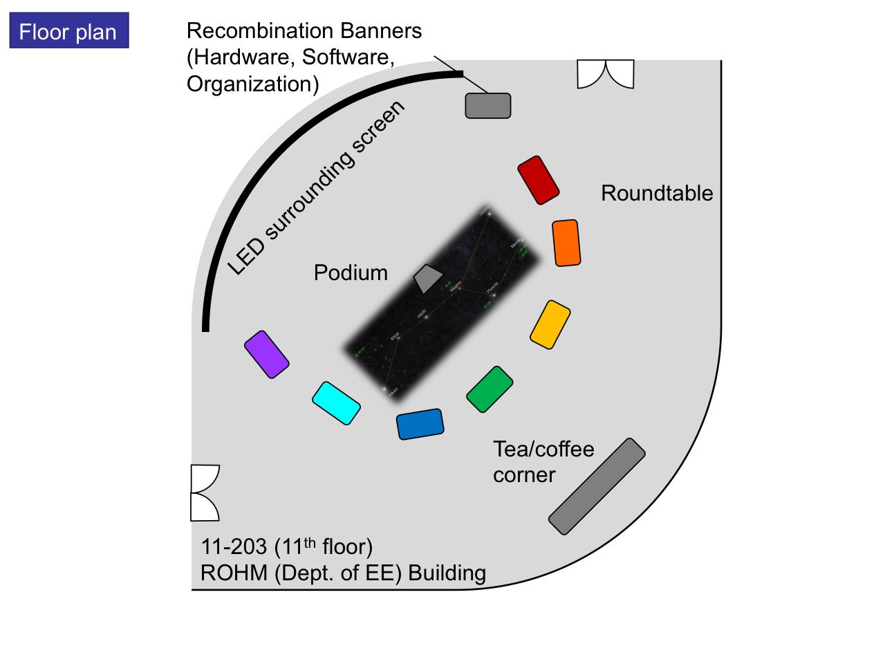

Venue floor plan

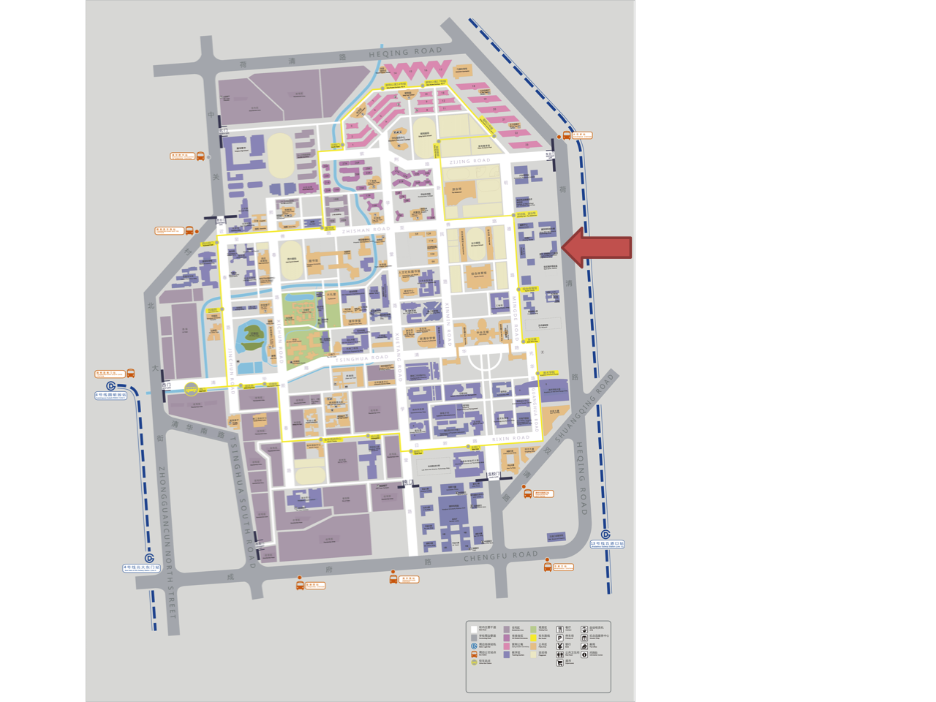

Campus map and venue location (电子工程系罗姆楼)